*Wasatch Front Travel Demand Model*

*Version 8.3*

INPUT DATA

Model Documentation

Updated: 2019-06-20

Table of Contents

**Traffic Analysis Zones (TAZ)** **4**

Key Zone Numbers 6

Zone Numbering 6

College Zone Numbering 6

Other Notable Zones 7

TAZ Shapefile Field Attributes 8

Default Large & Medium Districts 10

**Socioeconomic Data** **12**

Socioeconomic Input Files 12

TAZ-level Input Files 12

County-level Control Files 14

Creation of County Control Totals 15

Source Data 15

Residential 15

Employment 20

Population by Age Group 27

Creation of WFRC & MAG Projections 29

Real Estate Market Model (REMM) 29

Base Year Data 29

Forecasting 30

Socioeconomic Review 30

Creation of Box Elder Projections 33

Base Year Data 33

Forecasting 35

Median Income 38

K-12 School Enrollment 38

**Highway Network (Suzie, help from Tim)** **39**

Fields in Master Network 39

Link fields 39

**Transit Networks** **43**

**External Data Files** **44**

**Roadway Planning Segments** **45**

**Static Data Input Files** **46**

# Traffic Analysis Zones (TAZ)

The Wasatch Front travel model region covers the urbanized portion of Weber, Davis, Salt Lake and Utah Counties and the portion of the Box Elder County from Brigham City South (Salt Lake City-West Valley City, Ogden-Layton, and Provo-Orem Urbanized Areas). The region is divided into 2,881 Traffic Analysis Zones (TAZ). TAZ boundaries are defined based on Census geographies (block, block group and tract). Care has been taken so that TAZ nest within Census tracts wherever possible in order for more direct matching with Census data. TAZ boundaries are also defined by major transportation facilities (such as roadways or rail lines), major environmental features (such as rivers), and with underlying land uses. The relative size of the TAZ was also a factor in deciding new TAZ boundaries if the zone size was large and the zone was thought to have a significant amount of socioeconomic activity.

The size of TAZ varies from under 10 acres in the downtown to more than 100,000 acres in the mountain or lake zones. The average zone size is approximately 350 acres, which is a little over ½ square mile. Generally, TAZ in urban areas are smaller than in suburban and rural areas.

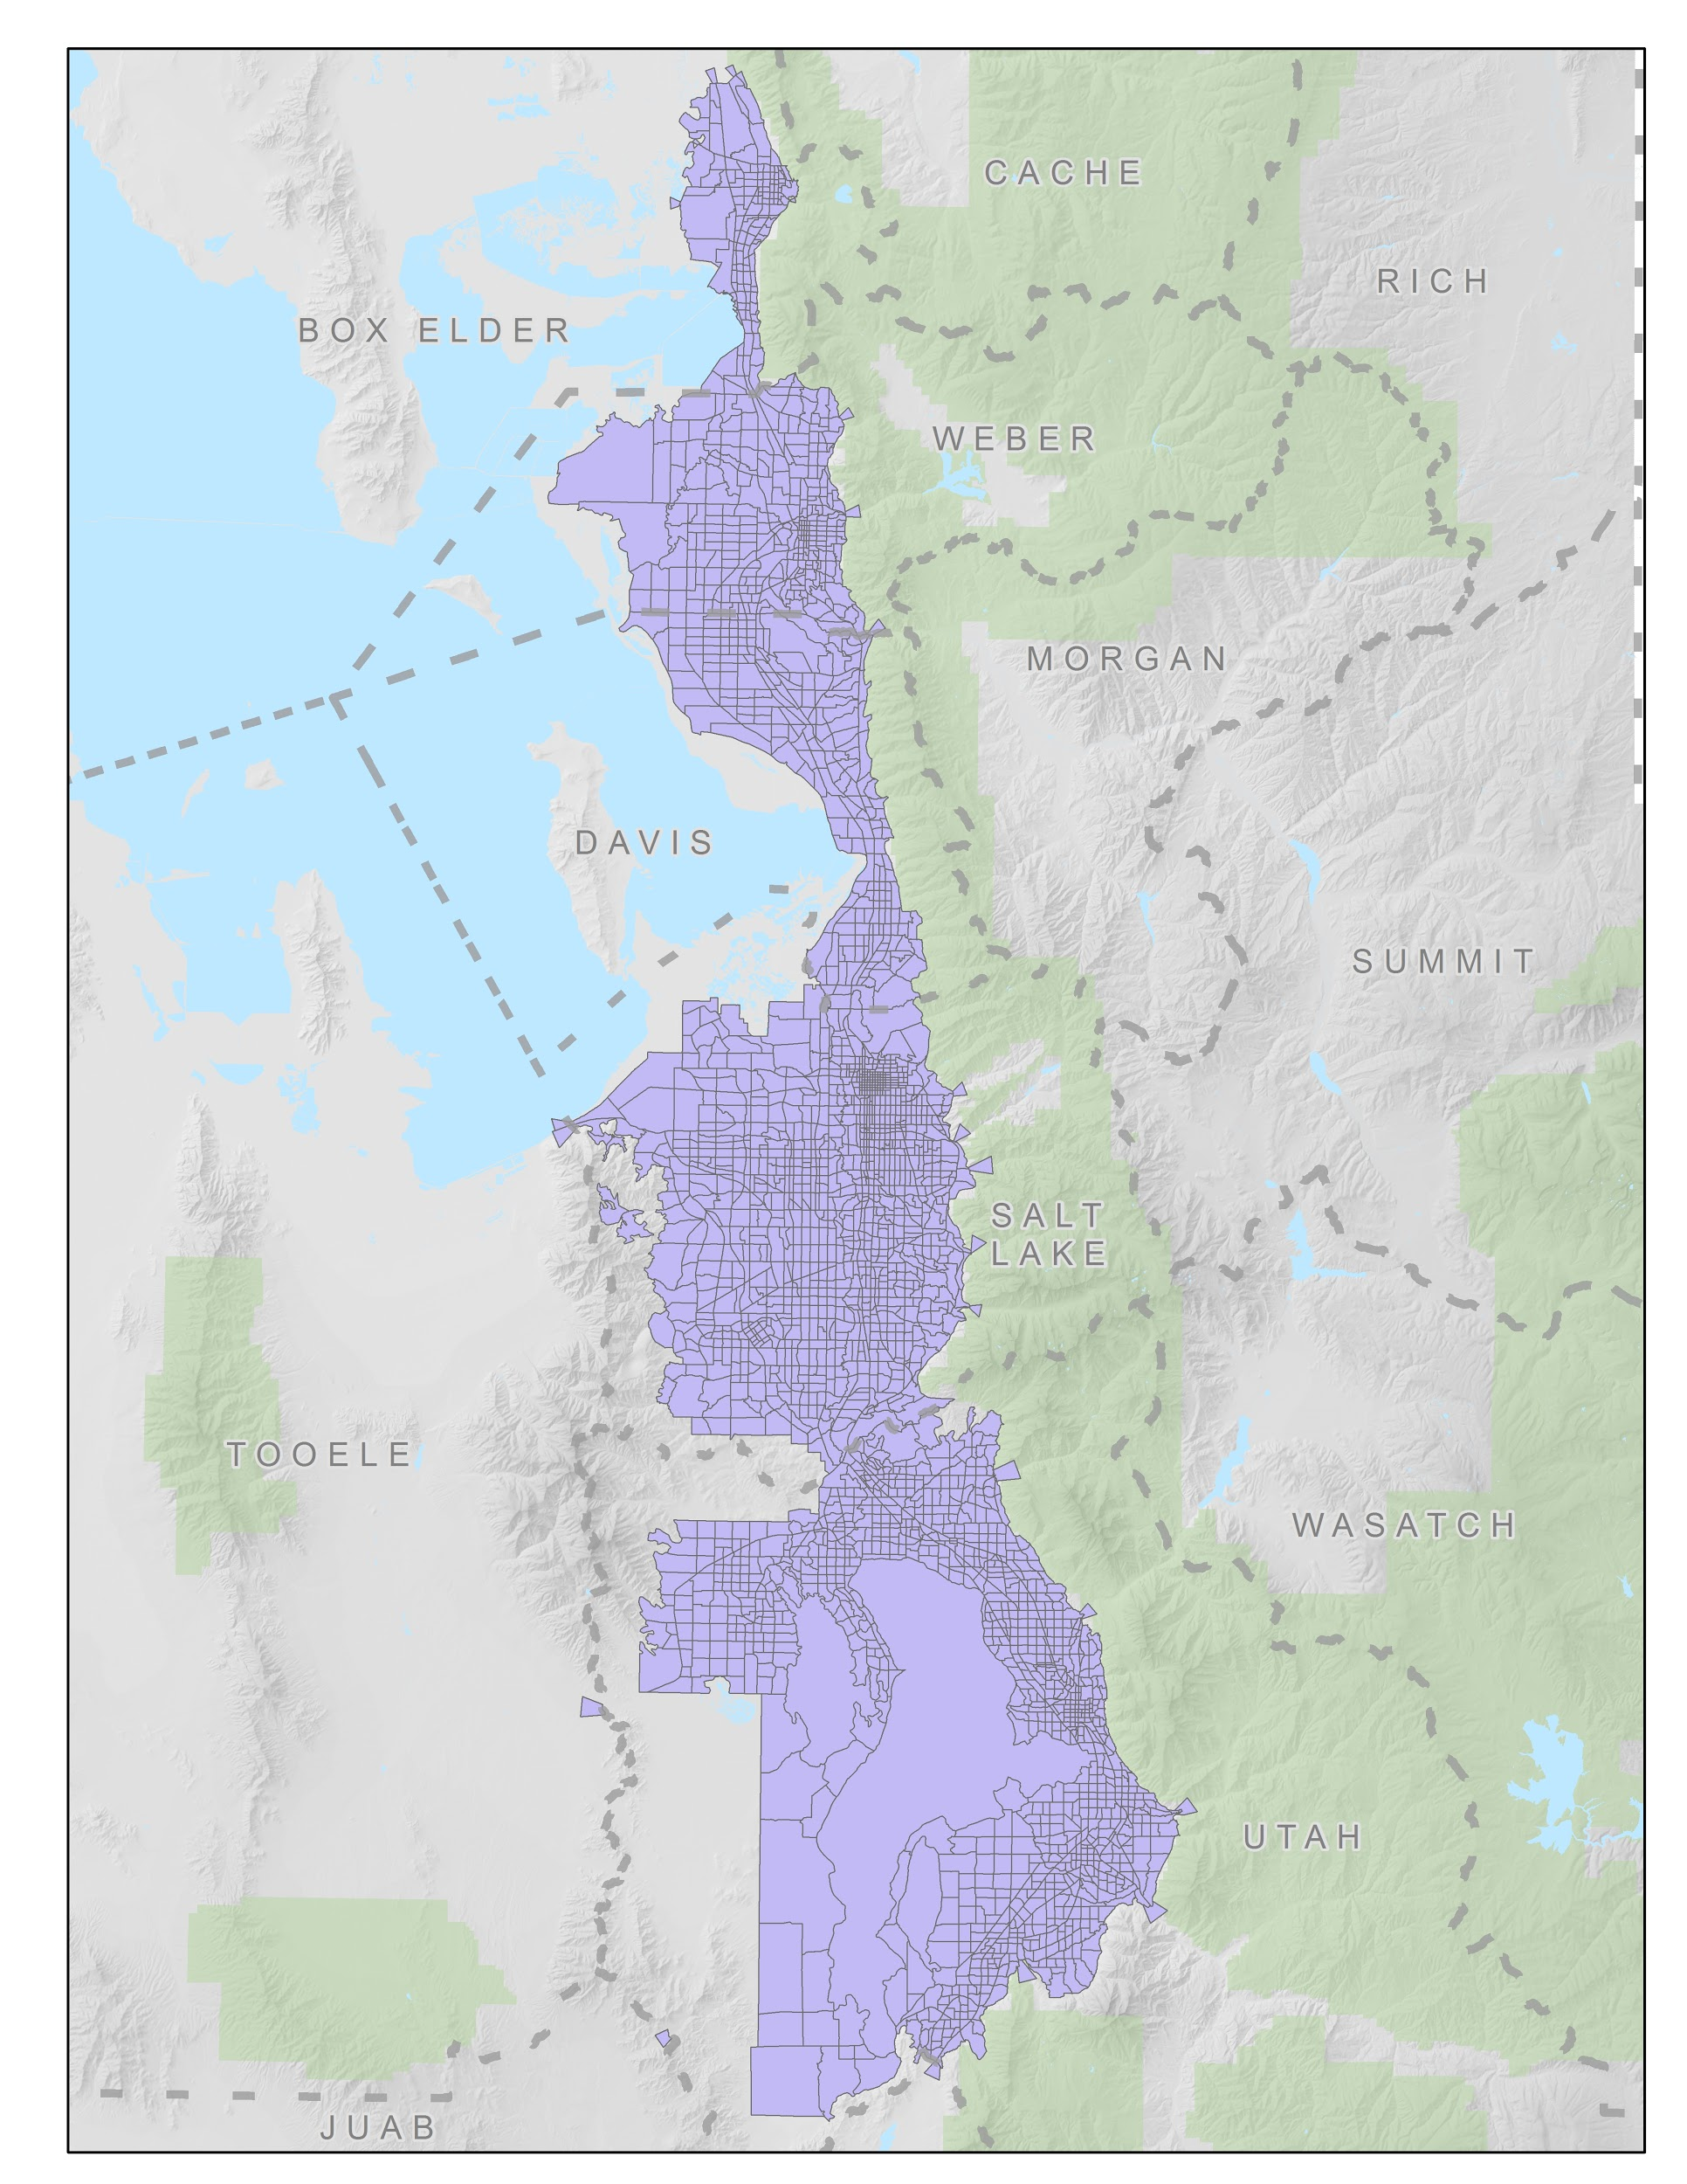

## Key Zone Numbers

The following are the zone numbers for key zones in the region:

### Zone Numbering

* Box Elder County 1-140
* Weber County 141-423
* Davis County 424-654
* Salt Lake County 655-1788
* Utah County 1789-2881
* External Zones 136-140, 421-423, 1782-1788, 2874-2881
  + Major Externals:
    - I-15 Box Elder 138
    - I-84 423
    - I-80 Tooele 1782
    - SR-201 Tooele 1783
    - I-80 East 1785
    - Provo Canyon 2875
    - SF Canyon 2877
    - I-15 Juab 2879
* WFRC Range 1-1788
* MAG Range 1789-2881

### College Zone Numbering

* LDSBC 950
* Westminster 1150
* U of U
  + Main 1075
  + Medical 1076
* WSU
  + Ogden 383
  + Davis 525
  + West 290
* SLCC
  + Taylorsville 897
  + South City 1126
  + Jordan 1493
  + Meadowbrook 1206
  + Miller 1516
  + Library Square 989
  + Highland 1294
  + Airport 746
  + Westpointe 745
  + Heriman 1607
* BYU 2384
* UVU
  + Main 2326
  + Geneva 2280
  + Thanksgiving Point 2099
  + Vineyard 2259
  + Payson 2690

### Other Notable Zones

* Lagoon 562
* Salt Lake International Airport 742
* Temple Square 966
* SLC Library 1015

## TAZ Shapefile Field Attributes

The TAZ shapefile comes with a set of predefined attributes:

* Identification variables
  + **TAZID** - zone number for Wasatch Front model space
  + **CO_TAZID** - zone number unique zone across all Utah model spaces (equal to *CO_FIPS * 10,000 + TAZID* for MPO areas and *CO_FIPS * 1,000 + TAZID or County Index* for non-MPO areas)
  + **SUBAREAID** - identifies model space, values include:
    - 0 - UDOT rural planning space
    - 1 - Wasatch Front
    - 2 - Cache
    - 3 - Dixie
    - 4 - Summit/Wasatch
    - *Other model spaces may be added in the future*
  + **EXTERNAL** - identifies external gateway zones
* Geometry variables
  + **ACRES** - total acres in zone
  + **DEVACRES** - developable acres in zone
  + **X** - x coordinate (in UTM) of zone centroid
  + **Y** - y coordinate (in UTM) of zone centroid
  + **ADJ_XY** - flag indicating if zone centroid coordinates were adjusted if the original centroid fell outside the zone (values: 1, 0)
* Model specific variables
  + **CBD** - identifies the central business district (values: 1, 0)
  + **TERMTIME** - override to the model’s terminal time (e.g. auto out-of-vehicle time) calculation expressed as an integer (values: 0 to max minutes specified for zone, non-zero values override the default calculation)
  + **PRKCSTPERM** - cost of permanent parking (paid parking structures or lots), used in HBW and HBC model choice model calculations, values in 2010 dollars and represent average user charge for the zone
  + **PRKCSTTEMP** - cost of temporary parking (parking meters), used in HBO and NHB mode choice calculations, values in 2010 dollars and represent average user charge for the zone
  + **WALK100** - override to the model’s percent of zone walkable to/from transit calculation, percentage expressed as an integer (values: 0-100, non-zero values override the default calculation)
  + **ECOEDPASS** - identifies the year a zone instituted an ECOPASS or EDPASS transit pass program, sets transit fares to zero in mode choice model for these zones (values: 4-digit year representing the year the program began)
  + **FREEFARE** - identifies the year zones in the downtown began free fare program (values: 4-digit year representing the year the program began)
* Geography specific variables used in summarizing data
  + **MPO** - identifies which MPO a zone is in, values include:
    - 1 - WFRC
    - 2 - MAG
  + **COUNTY** - identifies county a zone is in, values include:
    - 1 - Weber
    - 2 - Davis
    - 3 - Salt Lake
    - 4 - Utah
    - 5 - Box Elder
  + **CO_FIPS** - county’s Census FIPS designation
  + **CO_NAME** - county’s name (text)
  + **CITY** - identifies city a zone is in, expressed as an integer
  + **CITY_FIPS** - city’s Census FIPS designation
  + **CITY_NAME** - city’s name (text)
  + **DISTLRG** - identifies the Large District a zone is in, expressed as an integer
  + **DLRG_NAME** - Large District’s name (text)
  + **DISTMED** - identifies the Medium District a zone is in, expressed as an integer
  + **DMED_NAME** - Medium District’s name (text)
  + **DISTSML** - identifies the Small District a zone is in, expressed as an integer
  + **DSML_NAME** - Small District’s name (text)

## Default Large & Medium Districts

It is often helpful to aggregate TAZ-level travel model data into larger geographies to better understand various aspects of model results. The Model has default Large and Medium district sets that are part of the TAZ input shapefile. Alternate district sets can be developed in the TAZ shapefile and referenced in the scenario manager. As part of the scenario run, the travel model summarizes socioeconomic data and distribution trip tables by the Large and Medium district sets defined in the scenario manager.

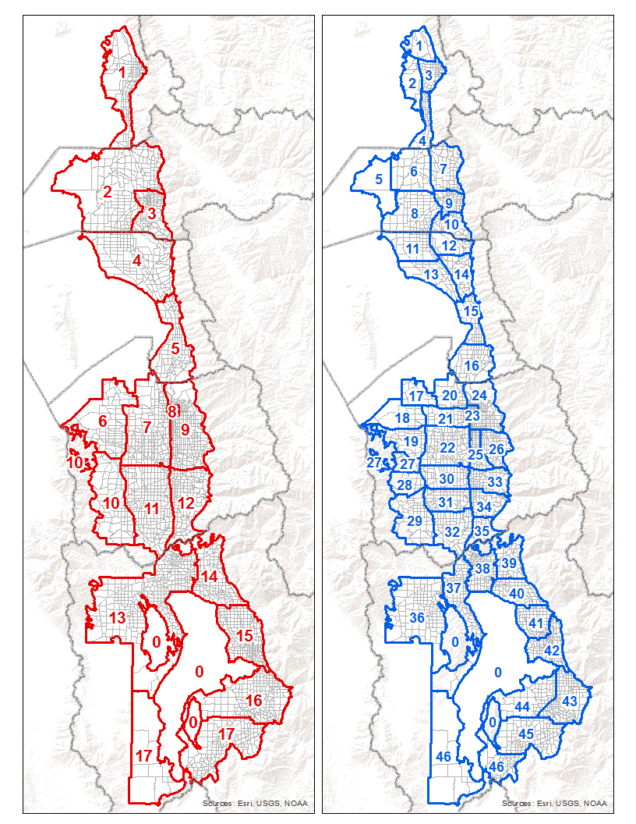

# Socioeconomic Data

The travel model uses residential and employment data to estimate travel demand. This socioeconomic data represents one of the key inputs to the travel model. This section describes the socioeconomic input files used by the travel model and the process that was followed to create them.

## Socioeconomic Input Files

The travel model has two sets of socioeconomic input files:

* *TAZ-level*
* *County-level*

### TAZ-level Input Files

A TAZ-level file is supplied for every year for which a model scenario is to be run. Each file includes the same data format and is similar to the data format used in the state’s other travel models.

The following lists the attribute fields that are included in each TAZ-level socioeconomic input file:

* Identification fields
  + **TAZID** - zone number for Wasatch Front model space
  + **CO_TAZID** - unique zone number across all Utah model spaces (equal to *CO_FIPS * 10,000 + TAZID* for MPO areas and *CO_FIPS * 1,000 + TAZID or County Index* for non-MPO areas)
  + **CO_FIPS** - county’s Census FIPS designation
  + **CO_NAME** - county’s name (text)
* Residential fields
  + **TOTHH** - the number of households in a zone
  + **HHPOP** - household population in a zone, does not include group quarters
  + **HHSIZE** - average household size of a zone (equal to HHPOP / TOTHH)
* Employment fields contain the number of jobs in a zone. These primary employment fields and summary or roll-up fields.
  + Primary employment fields, each of these are independently estimated in the socioeconomic data development process:
    - Used for estimating trip generation:
      * **RETL** - retail jobs
      * **FOOD** - food and accommodation jobs
      * **MANU** - manufacturing jobs
      * **WSLE** - wholesale and transportation jobs
      * **OFFI** - office jobs
      * **GVED** - government and education jobs
      * **HLTH** - health care jobs
      * **OTHR** - other jobs
    - Used in the commercial vehicle and freight models:
      * **FM_AGRI** - agriculture jobs
      * **FM_MING** - mining jobs
      * **FM_CONS** - construction jobs
    - Included to complete the accounting of all jobs, however these jobs are not used by the travel model
      * **HBJ** - home-based jobs
  + Summary or roll-up fields:
    - **ALLEMP** - all employment, the sum of all 12 employment categories
    - **RETEMP** - retail jobs (RETL + FOOD)
    - **INDEMP** - industrial jobs (MANU + WSLE)
    - **OTHEMP** - ‘other’ jobs (OFFI + GVED + HLTH + OTHR)
    - **TOTEMP** - total employment (RETEMP + INDEMP + OTHEMP), does not include agriculture, mining, and home-based jobs
* Income
  + **AVGINCOME** - TAZ median income
* Grade school (kindergarten through 12th grade or K-12) student enrollment variables:
  + **Enrol_Elem** - elementary school enrollment
  + **Enrol_Midl** - middle school (jr. high) enrollment
  + **Enrol_High** - high school enrollment

The TAZ-level socioeconomic input files are stored in the ‘1_Inputs\2_SEData’ folder. The data is arranged into three regions based on the source of the data:

* Box Elder
* WFRC
* MAG

It is important to note that one region’s input file may include data for zones that are in another region (this is often the case in the WFRC and MAG socioeconomic input files). Because the model only reads a zone’s data for the region where zone resides, any duplicate data in another region is ignored. Thus, updates to the socioeconomic data will need to be done in the set of files in the region where the zone resides.

WFRC and MAG regions include files for the years 2015 to 2050. The Box Elder region includes files for years 2010 to 2060 (2051 to 2060 are provided for long-range planning purposes only and are not part of the official Regional Transportation Plan data release). Each region has a unique variable in the model’s ‘1ControlCenter.block’ file to define the socioeconomic input file to be used for that region.

### County-level Control Files

The model contains two county-level input files, located in the model’s ‘1_Inputs\2_SEData\_ControlTotals’ folder:

* ‘ControlTotal_SE_WF.csv’ - socioeconomic variables by county by year
* ‘ControlTotal_Age.csv’ - population by age group by county by year

The ‘ControlTotal_SE_WF.csv’ input file is used for reporting deviation from the model’s TAZ-level socioeconomic data from the county control total. The fields in the control file include the residential and primary employment fields found in the TAZ-level socioeconomic files.

The ‘ControlTotal_Age.csv’ input file contains county population by three age groups:

* Children - 0 to 17
* Adults - 18 to 64
* Seniors - 65 +

This information is used in the model’s household disaggregation step and allows the model to adjust as the share of children, adults and seniors fluctuates over time.

## Creation of County Control Totals

### Source Data

The socioeconomic and age data used to create the county control total inputs to the travel model are based primarily on data developed and published by the Kem C. Gardner Policy Institute (GPI) at the University of Utah. The most recent county-level socioeconomic projections were released in July of 2017 and form the base assumptions for all socioeconomic planning statewide. Detailed methodology of the GPI process can be found on their website at <https://gardner.utah.edu/wp-content/uploads/udem_2017_final.pdf>. WFRC and MAG provided input data to GPI and reviewed outputs in the process of developing the 2017 baseline projections.

### Residential

The 2017 release of the GPI residential data included information for the following categories:

* Total population
* Group quarters population (institutionalized and non-institutionalized)
* Household population (total population minus group quarter population)
* Households
* Average household size
* Population by age

Household population, households, average household size and population by age are the primary fields used by the travel model and the ones used in the creation of the control totals. Total population and group quarters are not used.

The 2017 GPI data included projections for the years 2015 through 2065. Data for historic years (2010-2014) were also provided by GPI, though these were not part of the official 2017 projections. Data for years prior to 2010 (1990-2009) were obtained from previous historical model data records.

A portion of the county population lives outside the space covered by the travel model. The following percentages of the county’s population living outside the Wasatch Front model were used to adjust the residential control total for Weber, Davis, Salt Lake and Utah counties:

* Weber 3.00%
* Davis 0.00%
* Salt Lake 0.42%
* Utah 0.22%

A simplifying assumption was made that the proportion of the population outside the model space grows at the same rate as the population inside the model space for these counties. Thus, the share of the population outside the model space was fixed for all years. This share was calculated using the model’s base year data from 2015.

Because the proportion of the population of Box Elder County living outside the model space was substantially higher (roughly half), the control total for this county was adjusted based on the TAZ-level socioeconomic data. The calculated percent of the county total that lived inside the model space ranged from 48% in 2010 to 45% in 2050 (47% to 43%, respectively, for households).

The following charts show the residential control totals used by this version of the travel model:

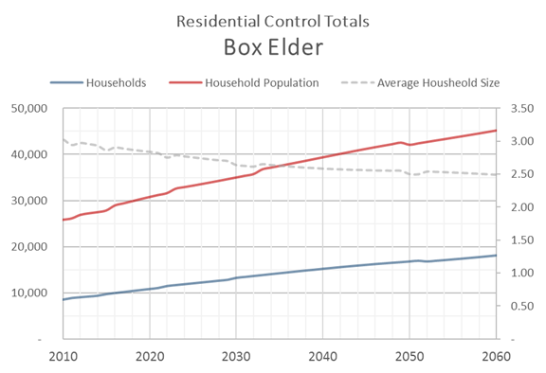

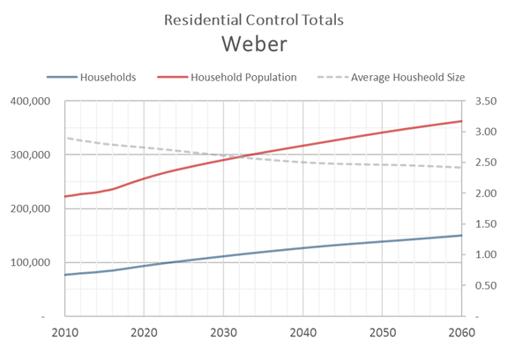

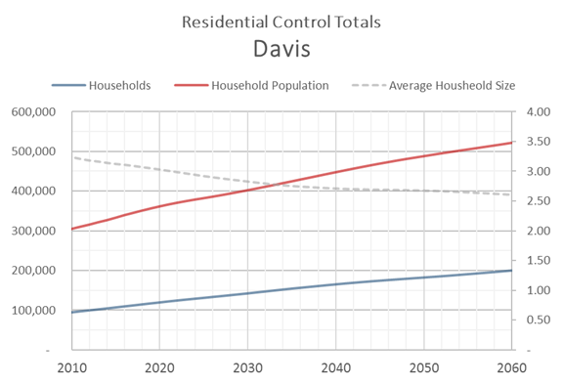

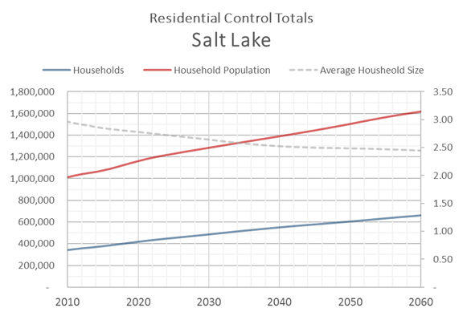

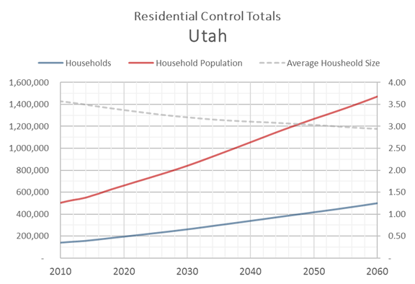

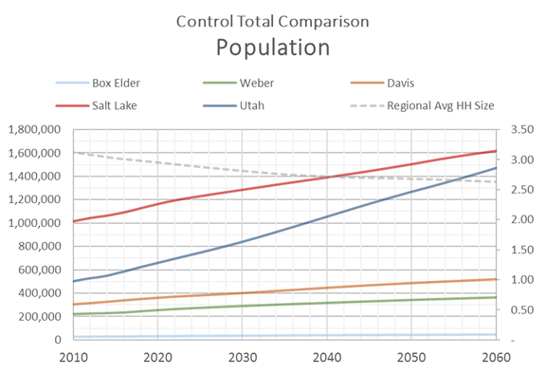

### Employment

GPI prepares employment data in two formats:

* Bureau of Labor Statistics (BLS) - does not include sole proprietors (e.g. business owners)
* Bureau of Economic Analysis (BEA) - includes sole proprietors

The travel model uses the BEA format for the employment control total as it represents a more complete definition of the employment.

The 2017 release of the GPI employment data included information for the years 2016 through 2066. Data for historic years (2001-2015) were downloaded from the BEA website. Data for years prior to 2001 (1990-2000) were obtained from previous historical model data records.

The GPI employment projections include 23 employment sectors. These sectors are aggregated into 11 employment categories for the travel model. The following lists the travel model control total employment categories and their associated GPI employment sector:

* **RETL**
  + Retail trade
* **FOOD**
  + Accommodations and Food Service
* **MANU**
  + Manufacturing
* **WSLE**
  + Utilities
  + Wholesale Trade
  + Transportation and Warehousing
* **OFFI**
  + Information
  + Professional and Technical Services
  + Management
* **GVED**
  + Education
  + Military
  + Federal Government
  + State and Local Government
* **HLTH**
  + Health Care and Social Assistance
* **OTHR**
  + Finance and Insurance
  + Real Estate
  + Administrative and Waste Services
  + Arts, Entertainment, and Recreation
  + Other services
* **FM_AGRI**
  + Agriculture, Forestry, Fishing and Hunting
  + Farm
* **FM_MING**
  + Mining, Quarrying, and Oil and Gas Extraction
* **FM_CONS**
  + Construction

A portion of the employment are at the household location and do not attract trips in the same fashion as employment at the jobsite. These home-based jobs are siphoned from each of the GPI sectors into a new category, **HBJ**, before the GPI data is aggregated into the 11 travel model categories based on the following percentages:

* Retail 2.5%
* Accommodations and Food 2.5%
* Manufacturing 1.0%
* Utilities 1.0%
* Wholesale 1.0%
* Transportation and Warehousing 1.0%
* Information 8.0%
* Professional and Technical Services 8.0%
* Management 8.0%
* Education 8.0%
* Military 2.5%
* Federal Government 2.5%
* State and Local Government 2.5%
* Health 8.0%
* Finance and Insurance 2.5%
* Real Estate 2.5%
* Administrative and Waste Services 8.0%
* Arts, Ent, Rec 8.0%
* Other services 8.0%
* Agriculture 0.0%
* Farm 20.0%
* Mining 0.0%
* Construction 1.0%

As with the residential control total, a portion of the employment in a county is located outside the space covered by the travel model. The calculation of travel model’s employment control totals uses the same logic and assumptions as the residential control total. The Weber, Davis, Salt Lake and Utah county percentage of all employment outside the model space are as follows:

* Weber 1.60%
* Davis 0.00%
* Salt Lake 0.22%
* Utah 0.22%

After the share of all jobs outside the travel model space was calculated for each county, the following percentages were used to determine the amount of employment in each sector. The source of this data was the 2015 Department of Workforce Services geocoded employment data.

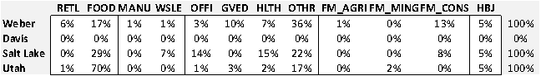

For the proportion of the Box Elder employment located outside the model space, a total percent by each employment subcategory was used. Percentages were based on the TAZ-level allocation. The 2010 and 2050 ranges are shown in the following table:



The travel model employment control totals were then updated to represent only the county employment within the travel model space.

The following charts show the employment control totals used by this version of the travel model:

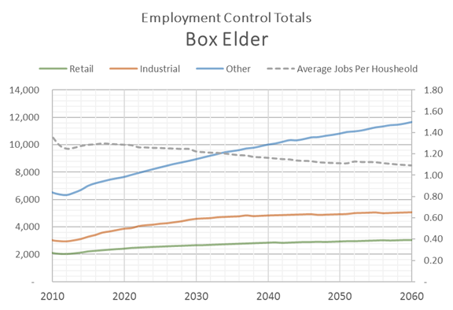

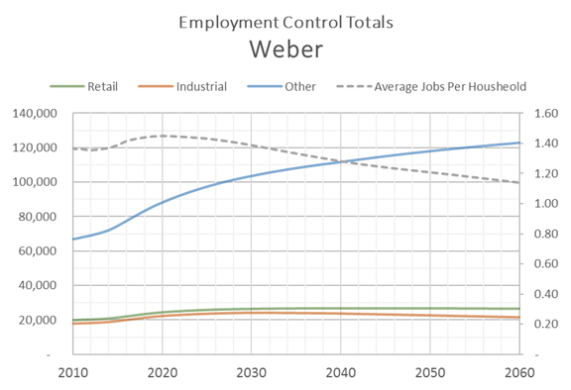

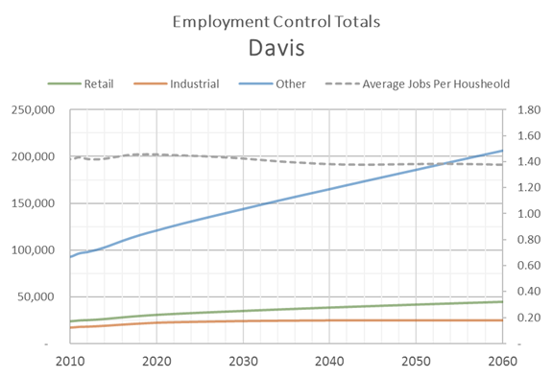

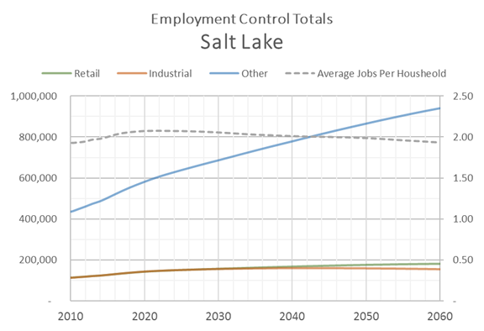

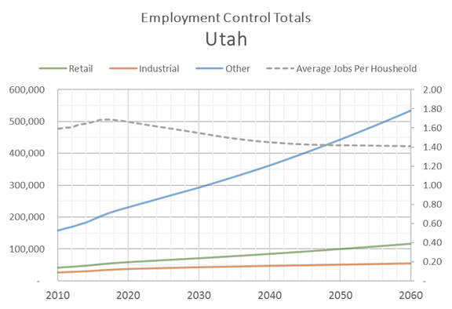

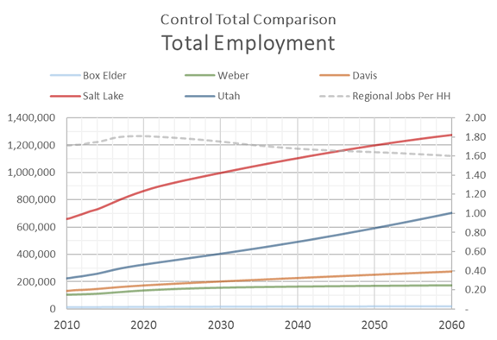

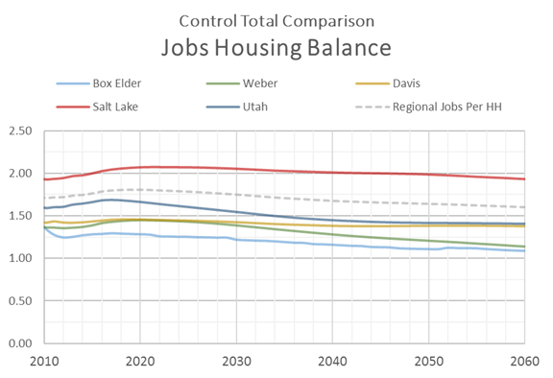

### Population by Age Group

The 2017 release of the GPI data included information for the years 2015 through 2065. Data for historic years (2010-2014) were also provided by GPI, though not part of the official 2017 projections. As mentioned previously, the population by age control total input file contains county population for three age groups:

* Children - 0 to 17
* Adults - 18 to 64
* Seniors - 65 +

No processing of the GPI data was needed to prepare the population by age group control total other than summing the GPI data into the three age ranges. An index was added to the control file to allow the model to look up the correct county and year in the data set. The index is formed by multiplying the CO_FIPS by 10,000 and adding the year associated with the record in the file.

The control total represents total county population. It does not differentiate between population residing inside or outside the model space. This is because the travel model uses this control file to establish the relative share of the population in each age group in a county for a given year. The actual population in the travel model is controlled by the county socioeconomic control file. The model makes the assumption that the population inside and outside the county will have the same relative share between age groups.

The population by age group control totals are presented in the following figures:

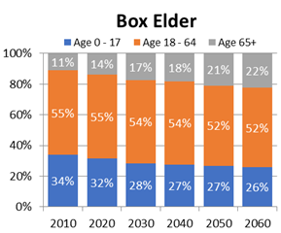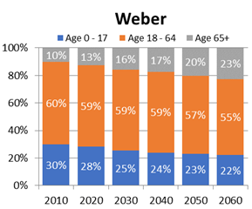

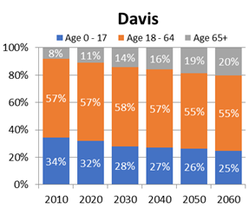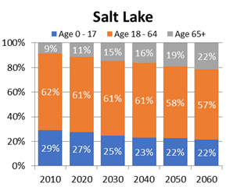

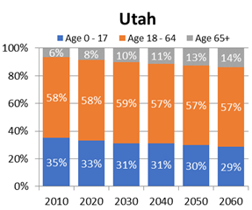

## Creation of WFRC & MAG Projections

General heading description...

### Real Estate Market Model (REMM)

General (brief) description of model process include graphics & with hyperlink to REMM documentation. Talk about the nature of model, e.g. it is an economic model, sensitive to transportation investment, etc.

### Base Year Data

Describe development of base year data sets

* DWS
* 2010 Census & XXXX year ACS
* Building permits
* Parcel data
* General plans and vision land use
* etc.

### Forecasting

Describe any specifics related to the development of the WFRC and MAG socioeconomic projections, including pipeline projects, vision zoning, etc.

### Socioeconomic Review

Review process:

* + - Staff reasonableness checks & Visual inspection
    - Expert panel
    - City review
    - Contractor/independent 3rd party review
    - General public?

Review led to edits to data sets.

Post processing process.

Results...Could also link to a separate document illustrating the city area charts for the various variables as well as a hyperlink to the SB34 data.

The following figures show the TAZ-level distribution of households and total employment for 2015 and 2050:

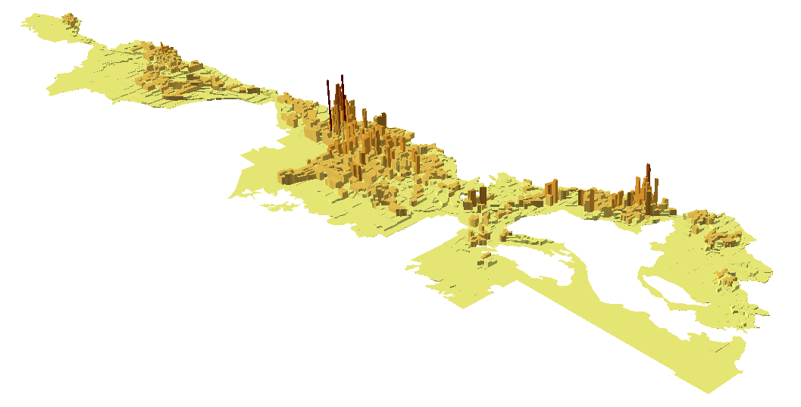

2015 Household Density

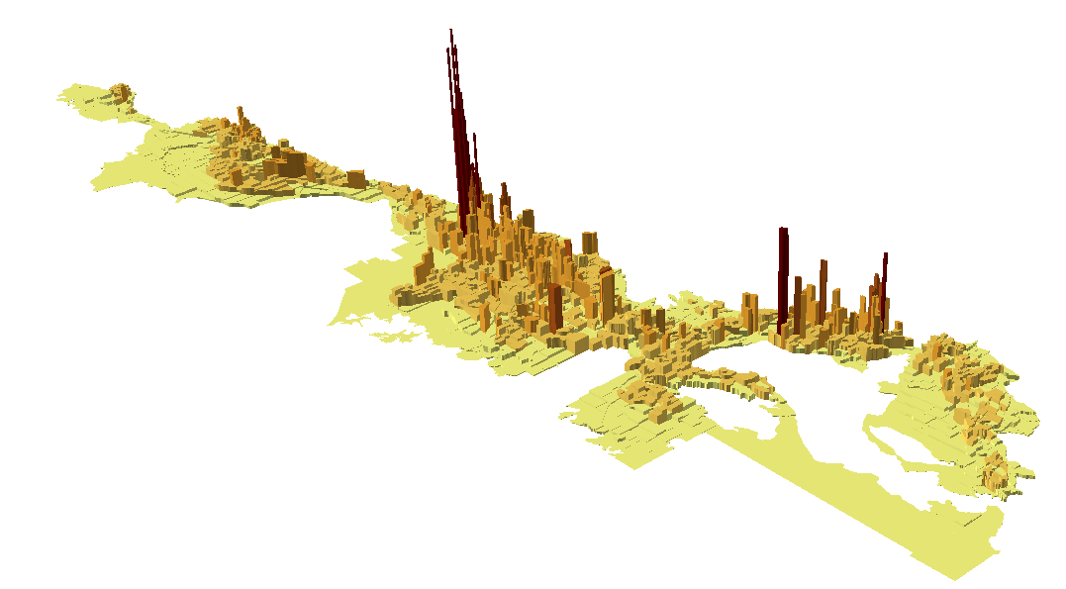

2050 Household Density

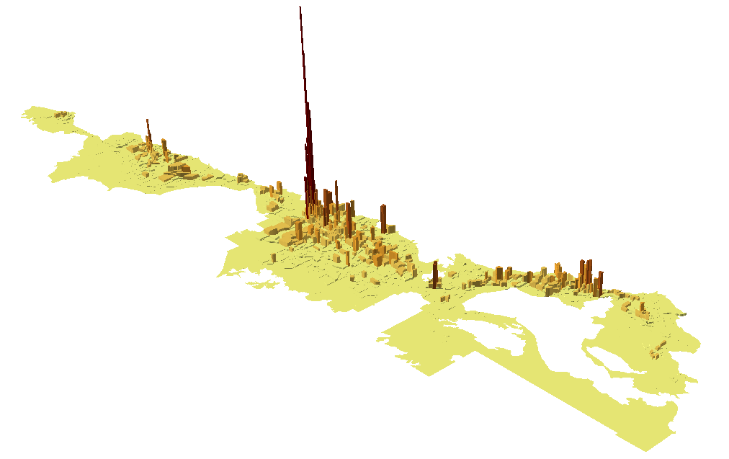

2015 Total Employment Density

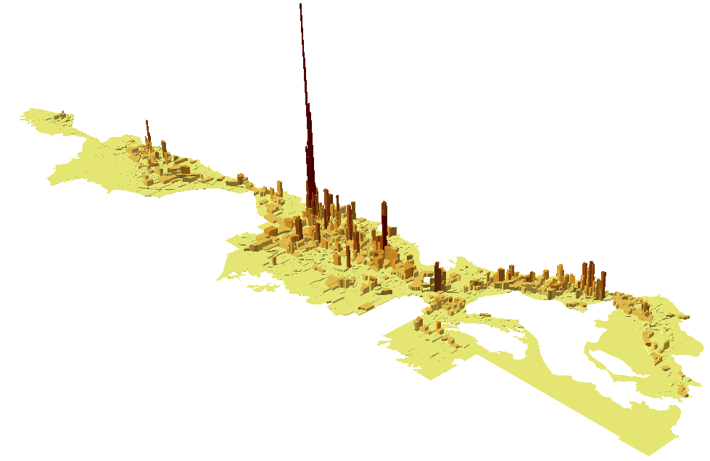

2050 Total Employment Density

## Creation of Box Elder Projections

The Box Elder socioeconomic projections were based on a spreadsheet allocation model. The model provided an automated means of disaggregating the county control totals into cities (i.e. city control totals) and then into TAZ while accounting for the holding capacity of the zone.

The TAZ-level socioeconomic allocations were performed by UDOT. The area of the county in the WFRC area, from Brigham City south, was then reviewed by WFRC and incorporated by WFRC into the Wasatch Front travel model.

### Base Year Data

**Residential**

Household and population data from the 2010 Census blocks were summarized into the model’s TAZ. Where TAZ boundaries split block boundaries, block data was proportioned into the appropriate TAZ. Housing vacancy rates were also tabulated to get a sense of occupancy rate and to estimate secondary homes. The TAZ-level households and population were then summarized by city and the balance of the county and compared to the city and county level control totals. Slight adjustments were made so the 2010 data matched the city and county controls. This provided a very accurate starting point of the location and amount of the area’s households and population.

Residential building permits provided an estimate of where household growth occurred between 2010 and 2015. As a permit to build a residential structure does not exactly equate to an occupied housing unit or household, these permits serve only as a proxy for household growth and to provide the relative distribution of growth in the area. Building permits are converted to households by adjusting to the household city and county control totals for each year.

Population is calculated in two steps, first by multiplying the TAZ’s households by the previous year’s average household size. This raw product is then summed and compared to the city and county control totals. An adjustment factor is then applied to the TAZ population. The TAZ average household size is then recalculated using the updated population and households.

**Employment**

The initial base year employment distribution was derived from two data sets:

* July 2015 release of the Quarterly Census of Employment and Wages (QCEW formerly ES-202) obtained from the Department of Workforce Services (DWS) - this report contains employment and wage data by industry from employers covered by the state’s unemployment insurance
* 2015 historic business data set purchased from Infogroup

Both the DWS and Infogroup data include the number of employees, physical address of employment and the firm’s industrial classification (NAICS). The addresses of the job sites were geocoded to provide the approximate geographic location and then summarized by TAZ.

Upon inspection of the two data sets, neither provided a fully accurate picture of the relative distribribution of the amount and type of employment in the county and the data were averaged to minimize error. Hand adjustments were also made if the employment data was in the wrong location or contained incorrect information.

The adjusted employment data set was summarized into the travel model’s employment categories using the following lookup of two-digit NAICS and model sector. Any data with an ownership code of 1-3 (federal, state and local government) was moved into the GOVED category to better align with GPI-based employment control total definition.

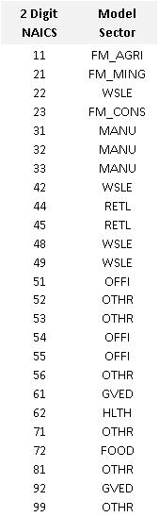

Some employment is not covered by unemployment insurance, such as farm or business owners (proprietors) and not included in the reported data. Therefore, the employment distribution from the observed data is used to define the pattern of employment rather than represent the full employment distribution. The full distribution for the 2015 base year was obtained by scaling the observed data to match the city and county employment control totals by category. For years prior to 2015 (2010-2014) the 2015 base year pattern was scaled to the control totals for each year.

### Forecasting

Residential

The spreadsheet model projects the location of future households. The model begins with the model base year and progresses sequentially to the furthest year in the time series. The model forecasts the change in TAZ households based on the following information:

* The annual change in households in a city or the balance of the county (city control totals)
* The household capacity (the maximum number of households) of each TAZ; this number can vary between years due to redevelopment, annexation or zoning changes
* The TAZ-level household growth rate
* Any user adjustments to the growth rate in a geographic area or to the absolute growth in a TAZ (e.g. to account for any known development events or to seed an area for growth)

The model first determines the raw or unadjusted number of new households in a TAZ by multiplying the previous year’s TAZ households by the growth rate for that TAZ that year. The growth rate is determined by a lookup curve that is a function of the relative amount of room left in a TAZ to grow or how close the zone is to its capacity. The growth rate curve is an S-shape with the highest growth rate for more empty zones and lower growth rates for zones that are close to capacity. The growth rate is zero for zones at capacity. The household capacity of a TAZ is determined from the base year household data, zoning and land use information, and aerial photography. The growth rate is then adjusted by any user specified growth rates for the zone.

The raw growth is then scaled to the change in the annual city-level household control total for the city in which a TAZ resides and added to the previous year’s households. If a user specifies the growth in a zone (zone seeding), this value is used instead of the calculated growth and the seeded number is removed from the annual growth total that is allocated to the rest of the city.

As with the base year population calculation, the TAZ-level population forecast is calculated in two steps. First the TAZ’s households in a given year are multiplied by the previous year’s average household size. This product is then summed and compared to the city control totals. An adjustment factor is then applied to the TAZ population so the sum of the adjusted TAZ equals the city control total. The TAZ average household size is then recalculated using the updated information.

Employment

The spreadsheet model uses a similar method to project the location of future employment as it did to project households. However, rather than projecting each individual employment sub-category, the model forecasts total employment (sum of the first eight employment categories) and then uses the base year’s share of the employment in each category to create an initial draft of the amount of employment in each of the employment subcategories. The model then uses an iterative proportional fitting routine to balance the TAZ total employment and the employment control total for the county by employment sub-category. The model adjusts the share of total employment in the eight employment sub-categories in each zone from year to year to follow the relative change in the county employment control totals. The user can also specify a new sub-category employment share for any TAZ if a development event changes the land-use of a zone.

The remaining job categories are allocated as follows: Agriculture and mining jobs use their 2015 base year distribution pattern to set the location of these jobs into the TAZ which are then scaled or adjusted to the city area control totals for each future year in the forecast. Construction jobs are located as a function of the absolute change in the TAZ’s households and employment. Home-based jobs are located based on the proportion of the TAZ households to the county’s total households.

## Median Income

TAZ average or median income is based on 2012-2016 5-year American Community Survey (ACS). Block group data was used to determine the initial geographic allocation of income. Where TAZ crossed block group boundaries, a weighted average of the block households assigned to each TAZ was used to more accurately proportion the block group income into the affected TAZ. The block group data was used to get an initial distribution of the TAZ median income. However, because block group level ACS data had a higher margin of error due to sample size, this data was scaled to the county median income which had a much better margin of error. A TAZ-level household weighted averaging was used to adjust the initial block group median income allocation to create the final TAZ median income allocation. Consumer Price Index (CPI) data was then used to scale the 2016 income to 2010 dollars.

## K-12 School Enrollment

The travel model uses student enrollment totals in a TAZ to identify the relative location where home-based school trips are attracted. Kindergarten through high school (K-12) enrollment is reported by three types of schools, each exhibiting different trip length and mode share attributes in the travel model:

* Elementary school
* Middle school
* High school

Public and charter school locations and enrollment data were obtained from the State Board of Education. Private school enrollment data was obtained from the Elementary/Secondary Information System (ELSI), a national database that reports enrollment by school and by grade. To obtain locations for private schools, their addresses were geocoded, manually locating poor matches and non-matches. A key was then created based on the school name and city in which the school resided to join the private school enrollment data to the private school locations.

The school data was then spatially joined to the statewide TAZ to create a school enrollment lookup database used by all the travel models in the state.

# Highway Network (Suzie, help from Tim)

* Concept of Master Network
  + Multiple scenarios
  + Share same link/node structure
  + Scenarios created by selecting which fields in the control center make up the scenario network

## Fields in Master Network

The Master Network is comprised of link and node data tables fused together in one Cube binary network. The following describes the link and node field attributes:

### Link fields

* Required Fields
  + A -- the node number of the beginning of the link
  + B -- the node number of the ending of the link
* Lane Fields -- the number of a facility’s general purpose lanes
  + Base year fields (LN_2015, LN_2019)
  + TIP fields (LN_2021, LN_2024)
    - LN19_30
    - LN19_40
    - LN19_50
    - LN19_30UF
    - LN19_40UF
    - LN19_50UF
    - LN19_50NNR
    - DISTANCE
    - STREET
    - ONEWAY
    - DIRECTION
    - TAZID
    - LINKID
    - SEGID
    - DISTEXCEPT
    - HOTZN
    - TRKRST2015
    - TRKRST2023
    - FT_2015
    - FT_2019
    - FT_2021
    - FT_2024
    - FT19_30
    - FT19_40
    - FT19_50
    - FT19_30UF
    - FT19_40UF
    - FT19_50UF
    - FT19_50NNR
    - TSPD_2015
    - TSPD_2019
    - TSPD_2021
    - TSPD_2024
    - TSPD19_30
    - TSPD19_40
    - TSPD19_50
    - HOT_2015
    - HOT_2019
    - HOT_2021
    - HOT_2024
    - HOT19_30
    - HOT19_40
    - HOT19_50
    - REL_2015
    - REL_2019
    - REL_2021
    - REL_2024
    - REL19_30
    - REL19_40
    - REL19_50
    - SFAC_BASE
    - SFAC_FUT
    - CFAC_BASE
    - CFAC_FUT
    - SEL_LINK
    - SCRN_LRG
    - SCRN_SML
    - OP_2019
    - OP_2021
    - OP_2023
    - OP19_30
    - OP19_40
    - OP19_50
    - OP19_30UF
    - OP19_40UF
    - OP19_50UF
    - OP19_50NNR
    - GIS19_30
    - GIS19_40
    - GIS19_50
    - FC_ID
    - SA_ID
    - TSPD_AVE
    - TRNSPD_PTC
    - TRNSPD_MIS
    - TRNSPD_MED
    - TRNSPD_HIG
    - TRNSPD_HII
    - EXTERNAL
    - MAG_LINK
    - WFRC_LINK
    - ANGLE
    - X_MID
    - Y_MID

# 

# Transit Networks

# 

# External Data Files

# 

# Roadway Planning Segments

# 

# Static Data Input Files

In addition to the TAZ-level socioeconomic input files, the model includes a TAZ-level base-year age profile input file, ‘Lookup - BYTAZAgePct - AllCo.csv’ located in the ‘1_Inputs\0_GlobalData\1_HHDisag_AutoOwn’ folder. This file is used in the household disaggregation step to calculate the TAZ’s initial population in three age groups:

* Children - 0 to 17
* Adults - 18 to 64
* Seniors - 65 +

The information in this file was based on data from the 2010 Census blocks. Where block population was less than 50, averages from the zone’s medium district were used in order to prevent potential skewing to the future data.

The ‘Lookup - BYTAZAgePct - AllCo.csv’ is a static data input